Quick Start Guide for Streeme+ IPTV
New for the 2022-23 academic year, all FDU residential students have access to Streeme IPTV streaming, the most powerful way to watch and record TV on campus. With Streeme IPTV residential students can watch live TV on any device, pause and rewind live TV, and record up to 20 hours of programming.
All residential students are automatically given access to the Streeme IPTV when they are given a housing assignment. This quick start guide will take you through the steps to begin your Streeme IPTV experience!
Before getting started, please make sure that your device is connected to the FDU Network either through Wi-Fi or an ethernet cable in your residence hall room as the Streeme IPTV operates from the FDU SSO platform. If you are logging into Streeme IPTV using a Smart TV or a TV with a Roku installed, please follow the steps in this video for additional information.
To get started, please make sure your non-FDU owned device is registered and connected to the FDU network. Additional information on how to do so can be found here
Rokus, firesticks, game console, etc. also need a non-pc device registration, to register a non-pc device registration please click here or here and then click on Non-PC Device Registration Form:

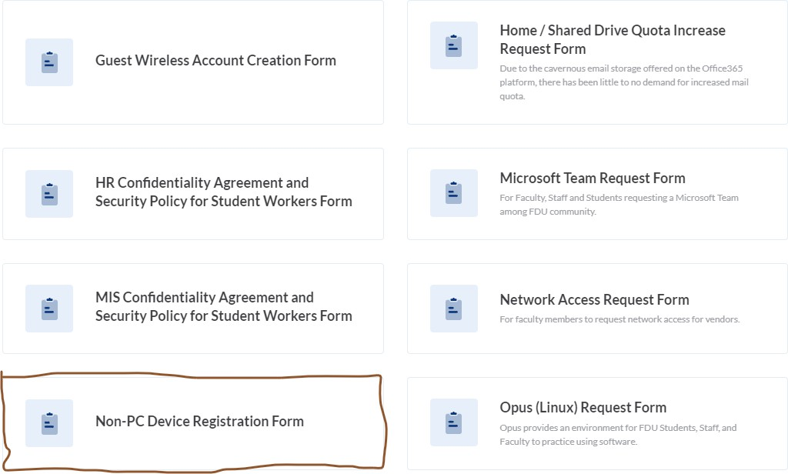

To Login into Streeme IPTV: Go to: play.streeme.tv

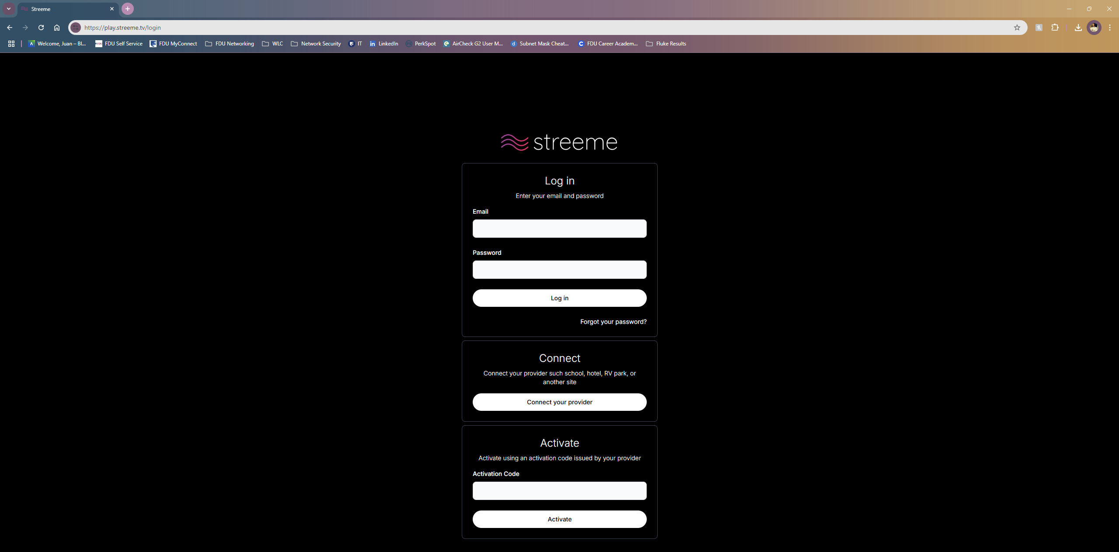

Click on the “Connect your provider” button inside the Connect box

On the next page, click on “Fairleigh Dickinson University”

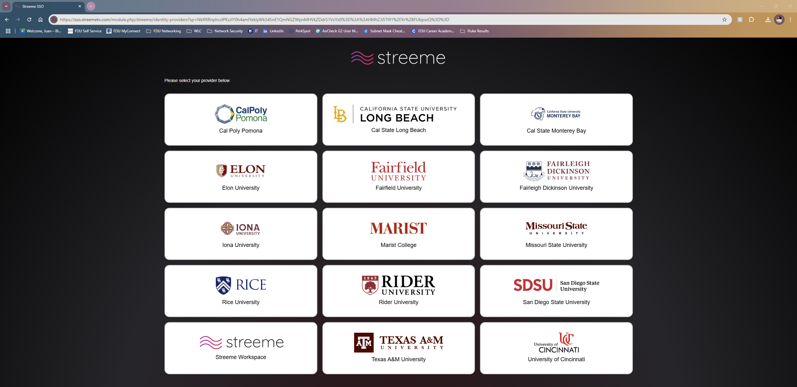

**Please be sure to click on Login via SSO rather than entering your login information on this page**

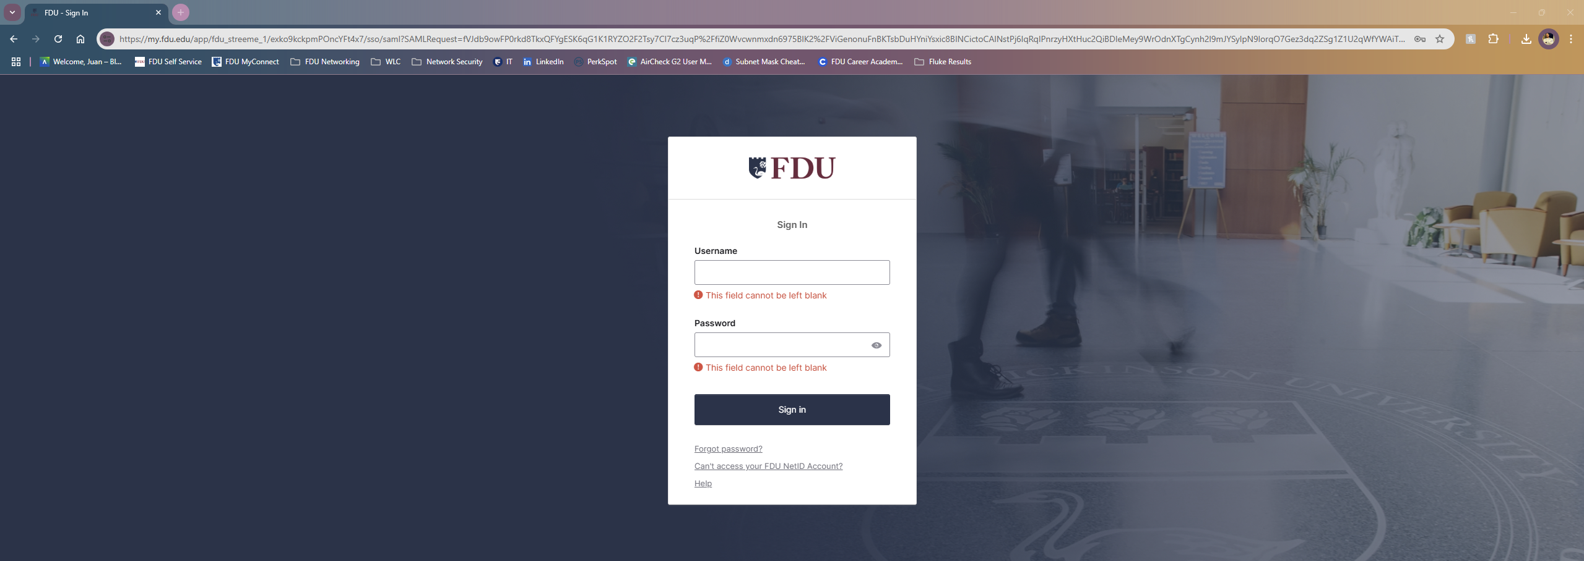
You will then be brought to the FDU Single Sign-On page where you will enter your FDUNet ID and password and complete the Duo Authentication process.
Please keep in mind that your device will need to be connected to the FDU Network either through Wi-Fi access or through an ethernet cable in your residence hall room for the authentication process to be successful.
Once you have logged in, you will see the channel guide and from there you can select the program you want to watch. 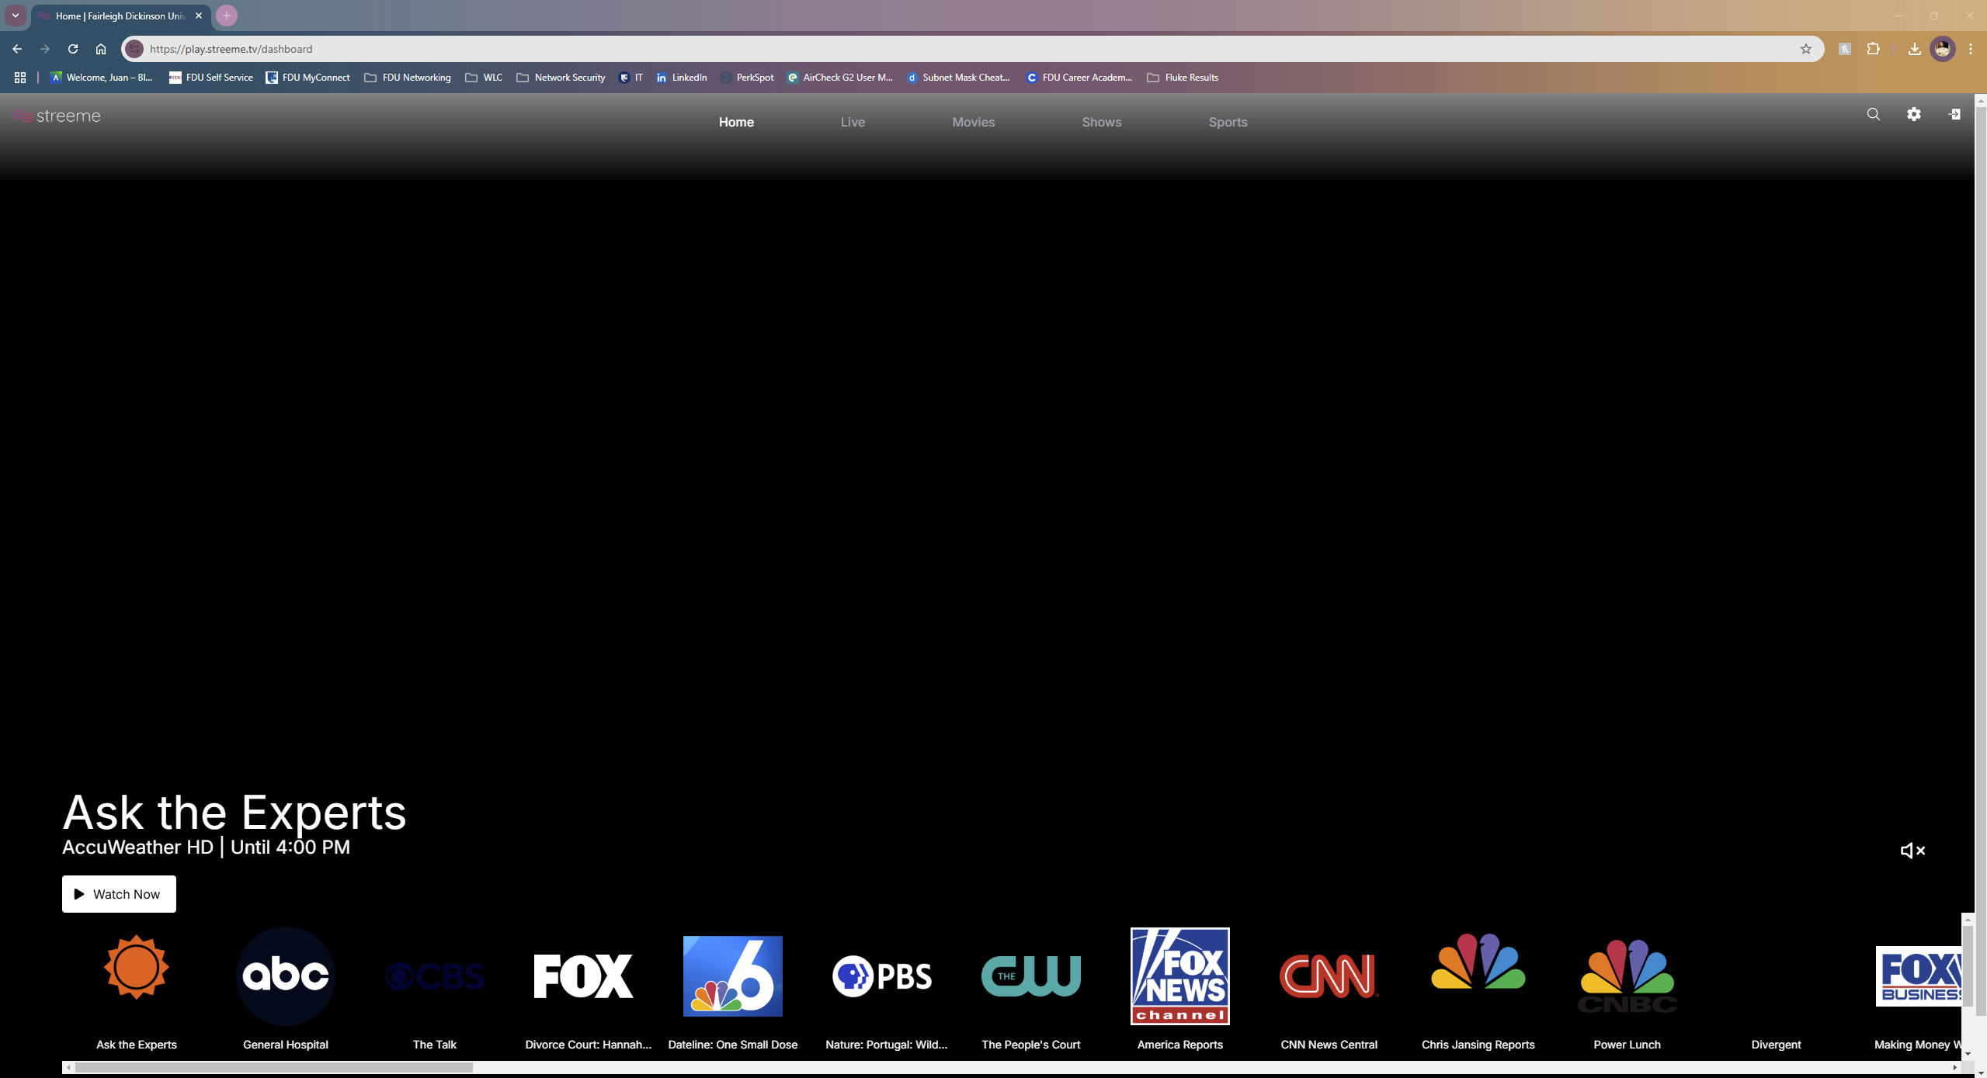
To view the full channel guide, click on the “Live” button on the top of the Page.

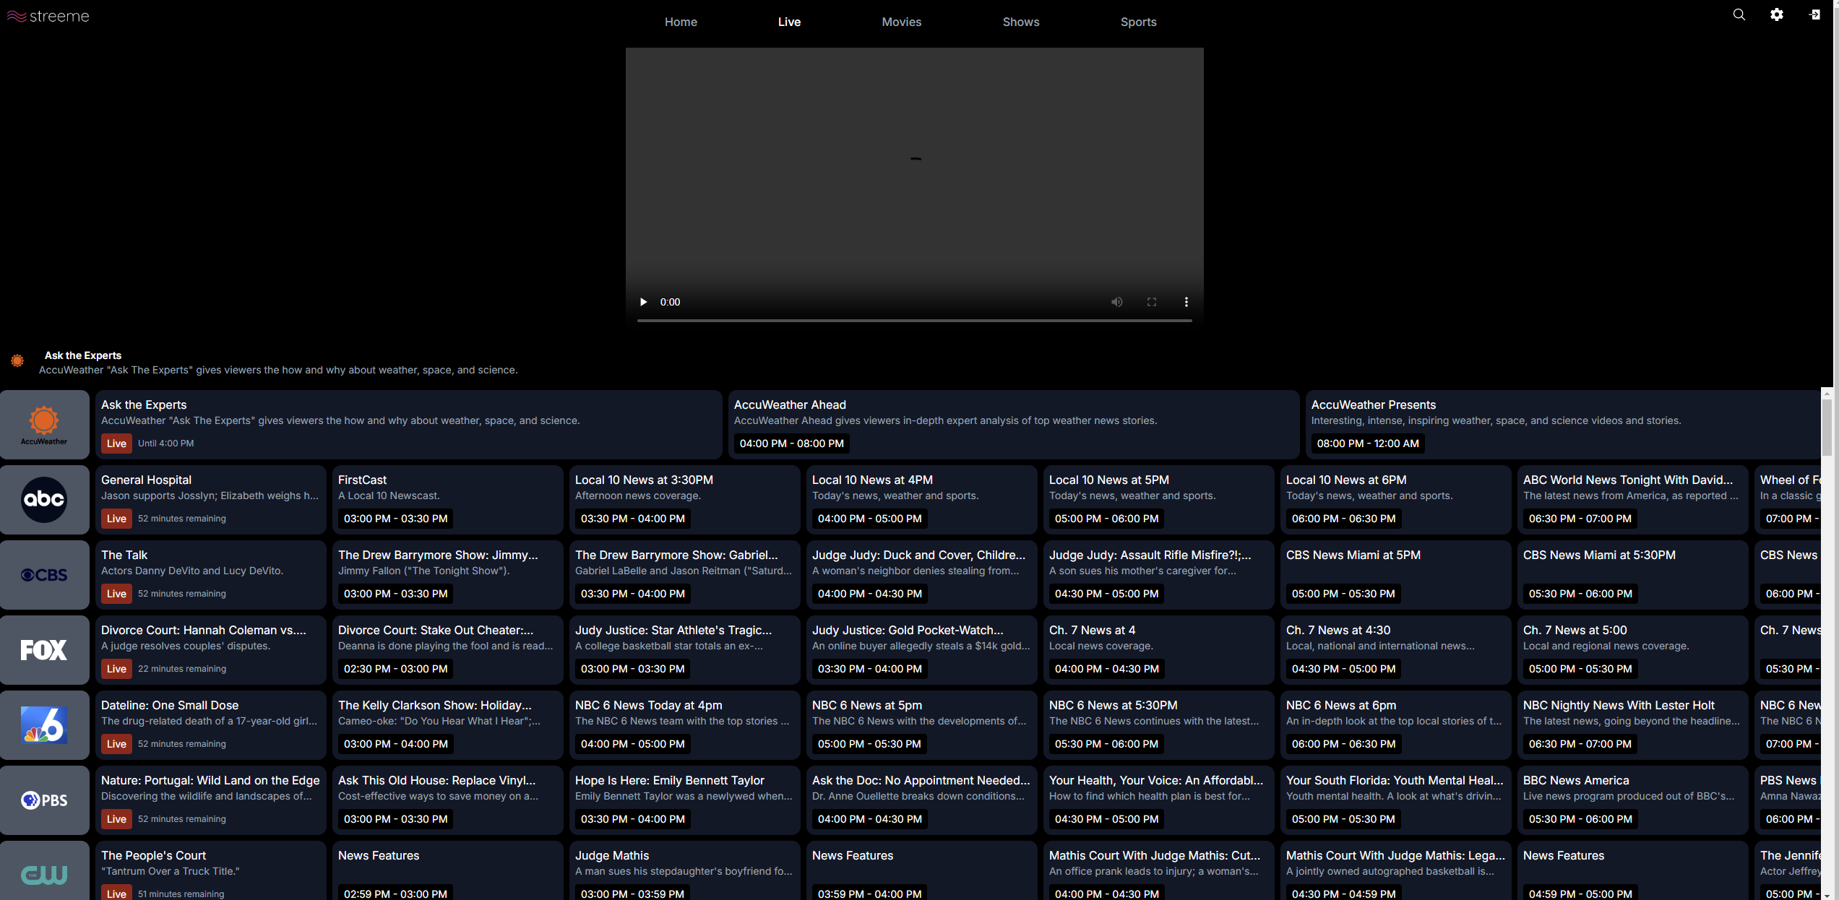

To view live, upcoming, or previously aired movies, click on the “Movies” button on the top of the Page.
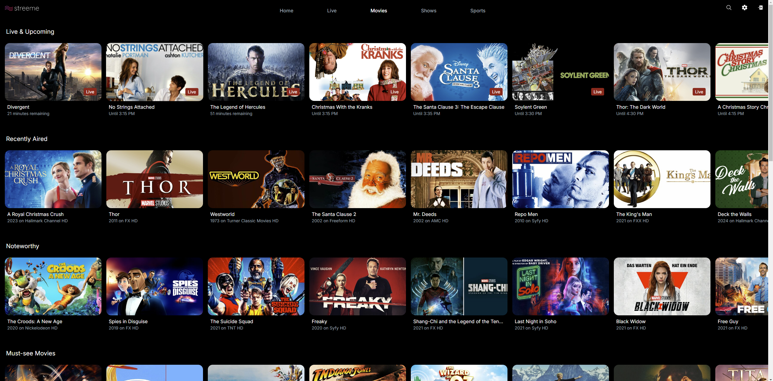

To view live, upcoming, or previously aired shows, click on the “Shows” button on the top of the Page.
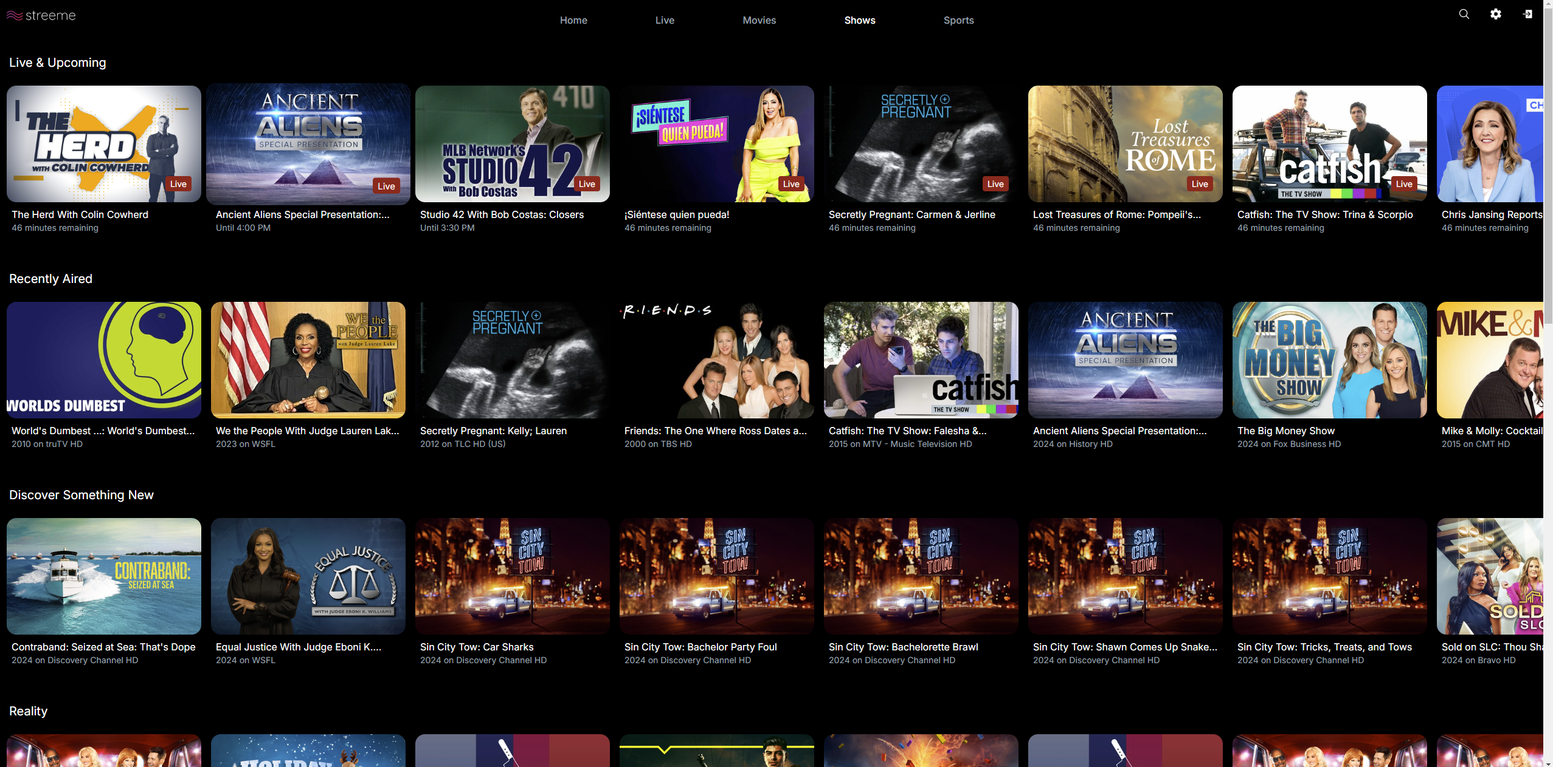

To view live, upcoming, or previously aired sports, click on the “Sports” button on the top of the Page.
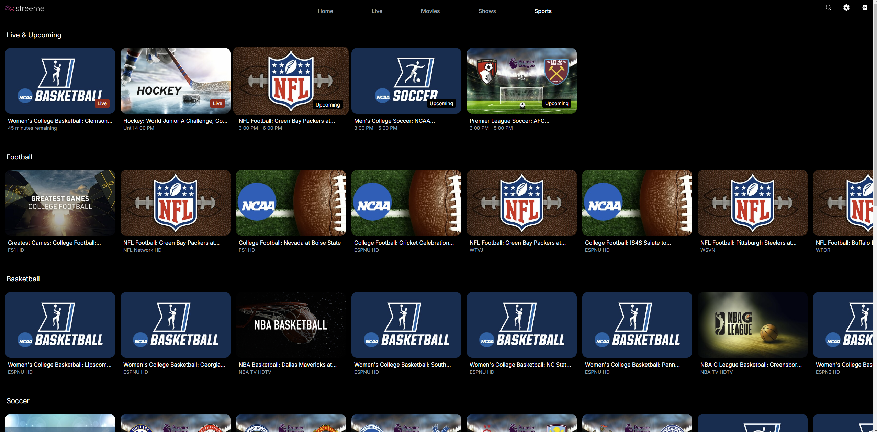
For additional assistance on how to navigate Streeme+ IPTV, check out the resources here! If you experience any issues with logging into Streeme+ IPTV, contact UTAC at 973-443-8822 or fdutac@fdu.edu

